**Macintosh HD:Users:luzm:Dropbox:CollaMine:budget:ITQ:Corporate-NYP-Logo_Horizontal.jpg**

**ITP213-03**

**Enterprise Application Development & Project Final Project Report**

Team Number: 05

Team Members:

Wang Yang 181192P (Group Leader)

Shaun Tan 184119X(Secretary)

Acee 182081W(Member)

Wei Jie 183340Z(Member)

Supervisor’s Name:

Mr Teh Ah Hock

Lastest report amendment date: 11 February 2020

**Documented by: Wang Yang**

Copyright Statement

1. Ownership of copyright:

Our team own the copyright in:

1. this website; and
2. the material on this website (including, without limitation, the text, computer code, images, artworks on this website).
3. Copyright license:

We grant to you a worldwide non-exclusive royalty-free revocable license to:

(a)View this website and the material on this website on a computer via a web browser;

(b)Copy and store this website and the material on this website in your web browser cache memory; and

(c)Print pages from this website for your own [personal and non-commercial] use.

We do not grant you any other rights in relation to this website or the material on this website. In other words, all other rights are reserved.

For the avoidance of doubt, you must not adapt, edit, change, transform, publish, republish, distribute, redistribute, broadcast, rebroadcast or show or play in public this website or the material on this website (in any form or media) without our prior written permission.

1. Data mining:

The automated and/or systematic collection of data from this website is prohibited.

1. Permissions:

You may request permission to use copyright materials on this website by writing to [181192P@mymail.nyp.edu.sg](mailto:181192P@mymail.nyp.edu.sg).

1. Enforcement of copyright:

We take the protection of its copyright very seriously. If We discover

that you have used our copyright materials in contravention of the license above, we may bring legal proceedings against you seeking monetary damages and an injunction to stop you using those materials. You could also be ordered to pay legal costs.

If you become aware of any use of our copyright materials that contravenes or may contravene the license above, please report this by email to [181192P@mymail.nyp.edu.sg](mailto:181192P@mymail.nyp.edu.sg).

1. Infringing material:

If you become aware of any material on the website that you believe infringes your or any other person's copyright, please report this by email to [181192P@mymail.nyp.edu.sg](mailto:181192P@mymail.nyp.edu.sg).

Contents

[Copyright Statement 2](#_Toc32425927)

[1. Ownership of copyright: 2](#_Toc32425928)

[2. Copyright license: 2](#_Toc32425929)

[3. Data mining: 2](#_Toc32425930)

[4. Permissions: 2](#_Toc32425931)

[5. Enforcement of copyright: 3](#_Toc32425932)

[6. Infringing material: 3](#_Toc32425933)

[Executive Summary 5](#_Toc32425934)

[Summary Of Application’s Functionality and Features 5](#_Toc32425935)

[Description of project innovation: 7](#_Toc32425936)

[Project Plan 8](#_Toc32425937)

[Project Team Organization 8](#_Toc32425938)

[Project Schedule And Task Allocation 8](#_Toc32425939)

[Software tools for development 9](#_Toc32425940)

[Requirement Analysis and System Design 10](#_Toc32425941)

[Use Case Diagram 10](#_Toc32425942)

[Database Modelling 14](#_Toc32425943)

[User Interface 15](#_Toc32425944)

[Future Enhancements 26](#_Toc32425945)

[Conclusion 27](#_Toc32425946)

**Documented by: Wang Yang**

Executive Summary

Summary Of Application’s Functionality and Features

NYP Journey summary functions and features are user identification system, user profile, wallet, question forum, management tools, notification menu, shop, ranking, invitation system, reporting pages and credit system.

User identification system:

User register and login the account by key in correct credentials with their corresponding Admin Number(For Student)/NRIC(For Teacher). User can find back their password by receiving system’s email.

User profile:

User can customize their own head icon and leave comment under other users’ profile. The profile contains users’ posted blogposts and brief data statistics about what have user done in NYP Journey. User can also add their favorite blogposts to favorite section.

Wallet:

User can check their own transaction history about their credits and shop purchase history which generate as Invoice. User can also top up their credit balance using PayPal.

Question Forum:

User posts question with a credit reward, after being approved by management system, other users can answer the question and one of them will be picked as the best solution and claim the credit reward.

Management Tools:

In order to manage the massive data more effectively, NYP Journey has a system that can only be accessed by admin account. The system can let the admin check the statistics of the website by data visualization. It is also able to edit all users’ information, posts and check the credit transaction record.

Notification menu:

Users check their own action record in NYP Journey and can redirect to the corresponding page.

Shop:

User redeem the credit for learning resources and the purchase invoice will be saved inside Wallet>Invoice.

Ranking:

User can see the overall ranking about users, blogposts and question forum in NYP Journey.

Invitation system:

Users invite their friends who have not yet get into NYP Journey with a invitation code. Both the new user who key in the code and the invitation code owner will be rewarded extra credit.

Reporting pages:

User can feedback in the questionnaire page and can type in if any issue occur in contact page.

Description of project innovation:

Due to consistent increment of Polytechnic Students, more requirements will be needed by Campus Community. Many individuals are now not fulfilled by the limited knowledge on paper and are struggled in finding a platform to guide them to study further in their interested aspects as well as find someone that can help you. In order to increase the opportunities of interaction between all teachers and students, make it much convenient, a new Web-based application need to be developed.

Therefore, We came up with an web-based platform to solve these inconveniences. NYP Journey ease the users within campus by establishing a communication platform for users to investigate their academic concerns and share their learning experience. This idea is derived from question and answers sites like stack overflow and Quora which users can ask questions in different aspects and professionals can solve their problems. Furthermore, we would like a system that can encourage the users to interact with the platform more actively just like Grab. We hope that the platform can combine the advantages of the pure question & answer site and well-known service site to build a unique platform and bring convenient service to the users.

**Documented by: Wang Yang**

Project Plan

Project Team Organization

Module Group: IT213-03

Project Team No: 05

Project Team Name: One For All

1: Wang Yang (Team Leader) 181192P Contact Number: 96100834

2: Shaun Tan 184119X Contact Number: 93233878

3: Wei Jie 183340Z Contact Number: 82229995

4: Acee 182081W Contact Number: 93798282

Project Schedule And Task Allocation

**Wang Yang:** Sign Up, Login, Forget Password, Invitation Code, UI design & Master Page, Index page & about us, Profile system, Notification Menu, Blogposts, Question & Answer Forum, Wallet system, Management Tools, Shopping cart & Invoice, Ranking board

**Shaun:** Shop Database, UI design of Shop Detail Page

**Wei Jie:** Questionnaire Page

**Acee:** FAQ Page, Contact Page

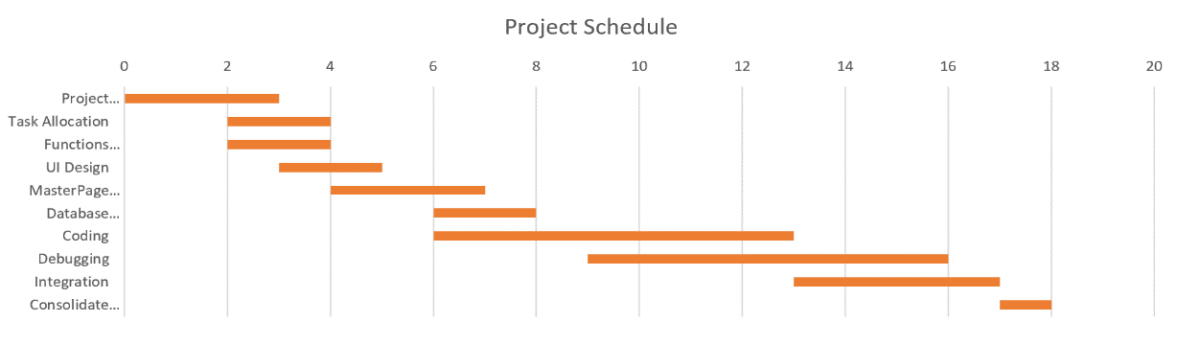

Software tools for development

IDE: Microsoft Visual Studio 2019

Web-Development Language:

-ASP.NET Webform + C#

-HTML + CSS + JavaScript

-Bootstrap:

1)Material-kit Pro

2)Keen

-PayPal Sandbox Checkout API

-TinyMCE Rich text Editor

Database: SQL Server 2018

Runtime Environment: Microsoft .NET Framework SDK v4.7.2

**Documented by: Wang Yang**

Requirement Analysis and System Design

Use Case Diagram

**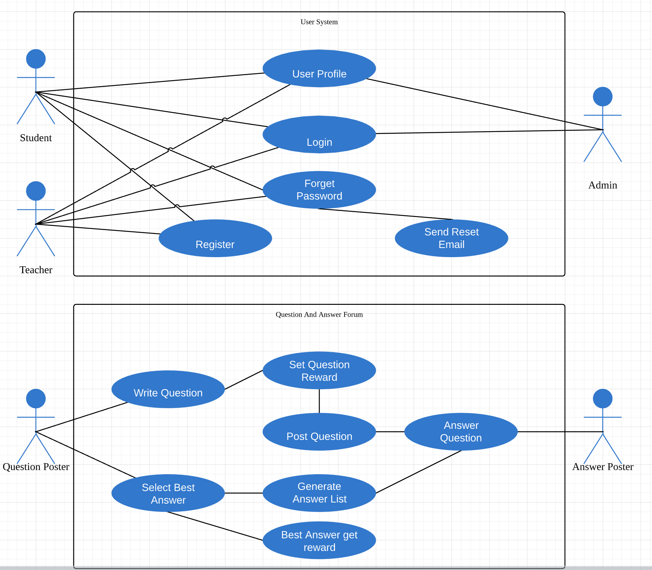**

**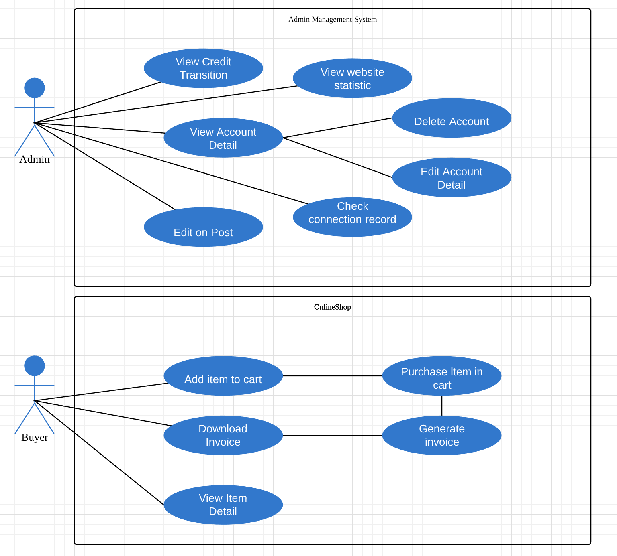**

**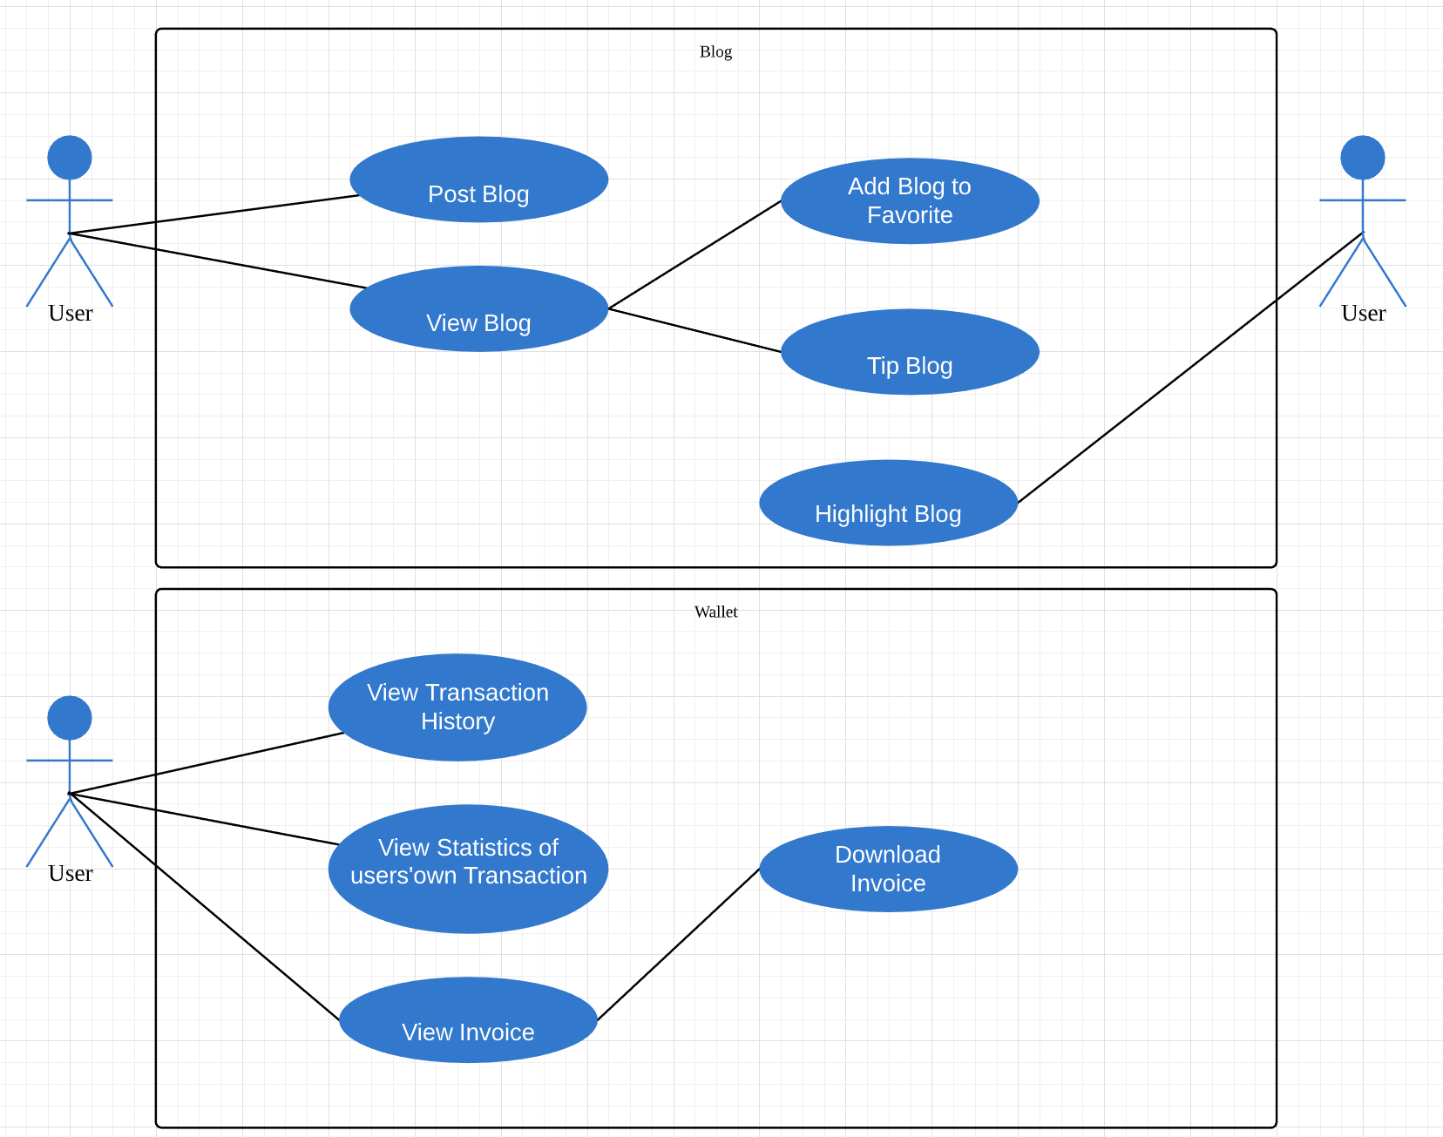**

**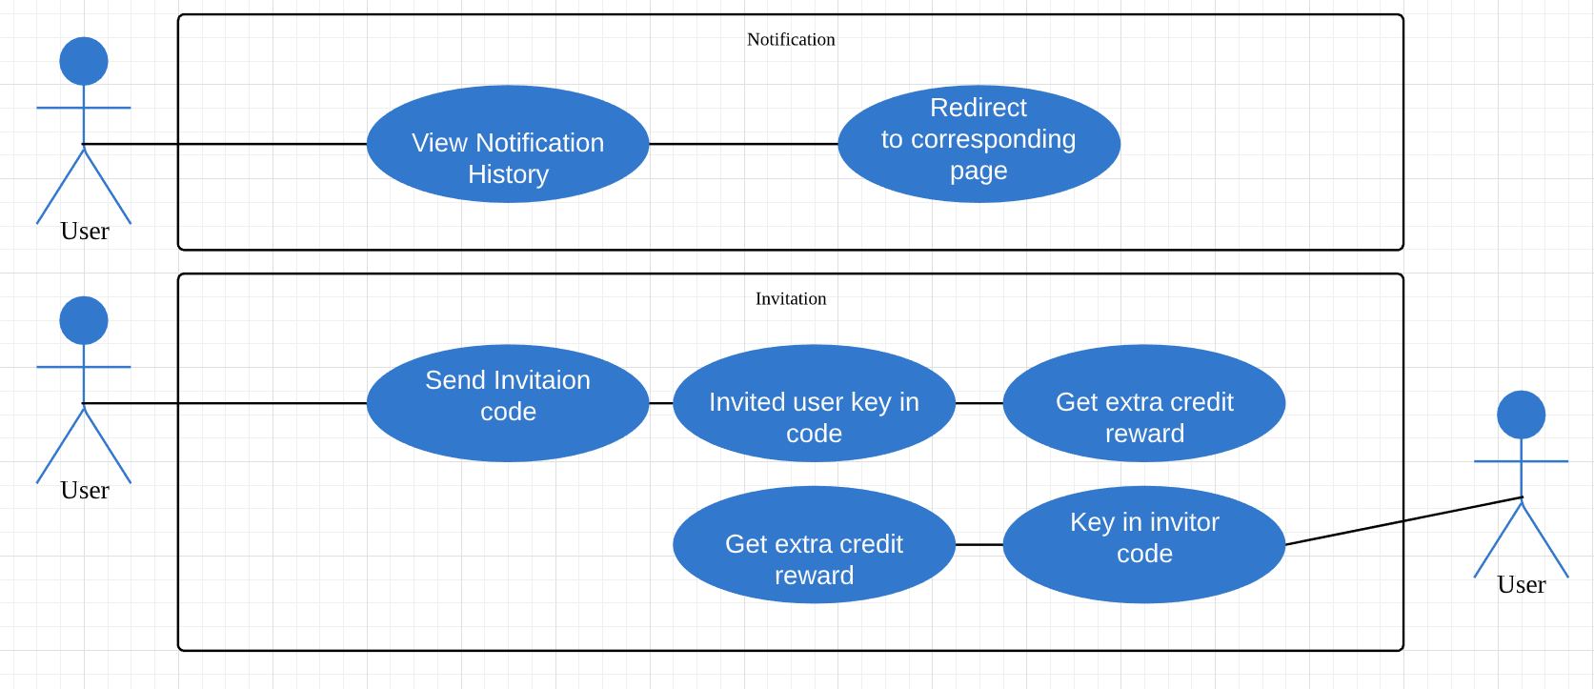**

Database Modelling

User Interface

User register account according to their roles, students will use their admin number as username, teacher will use their NRIC

.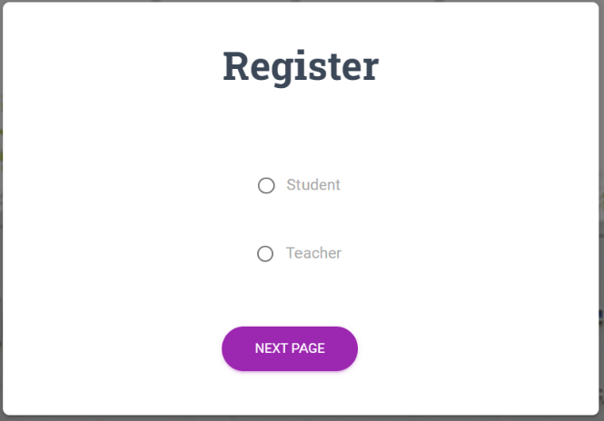

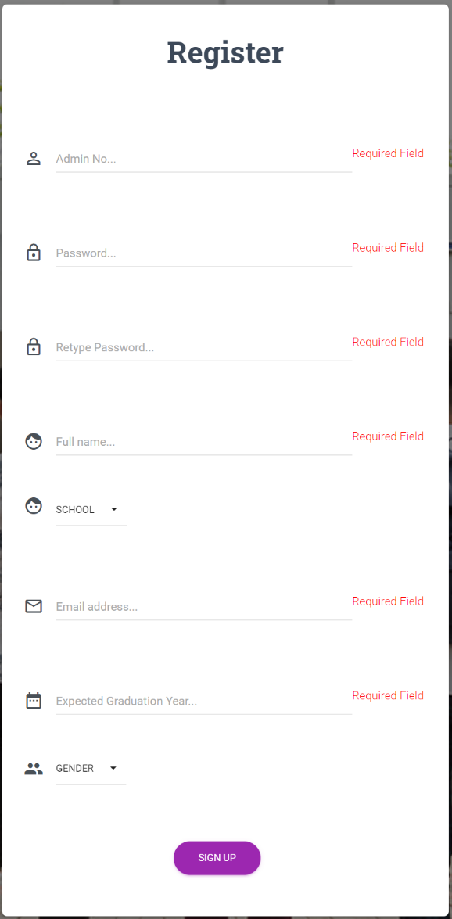

Once registered, the account will automatically sign in.

User can also login the account. If they forget their password, system will send password to their emails.

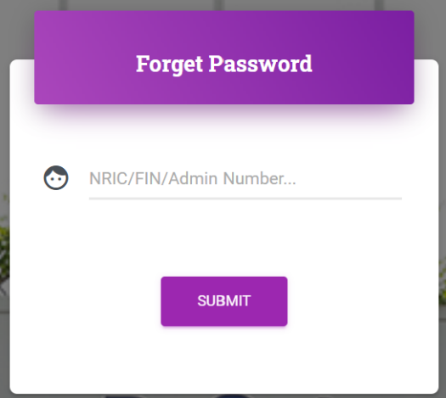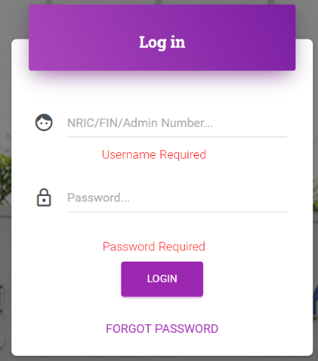



User can change their default head icon or write blogs in profile page, and can leave comment under other users’ profile page

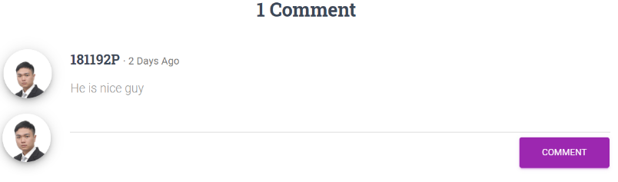

User can ask question in Let’s Ask forum.

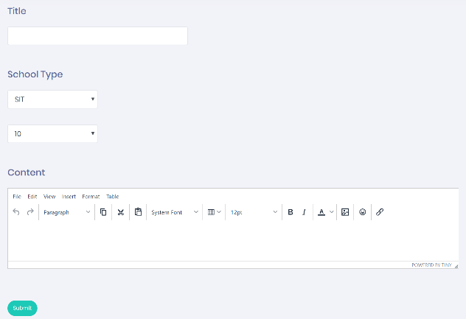

After the question been submitted, it will be review by administrator, if the question is approved, it can be seen by all users.

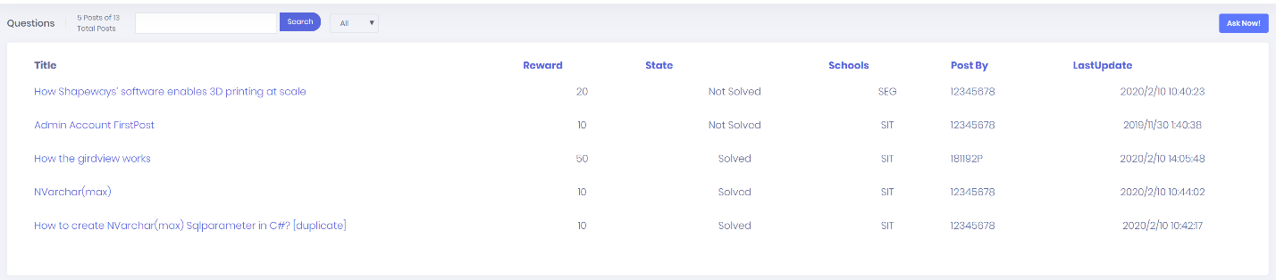

All user can answer the question and the best solution for the question poster will claimed the reward. User can also leave reply under the answer.

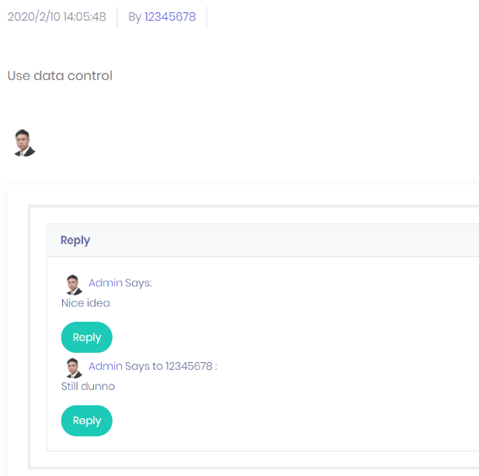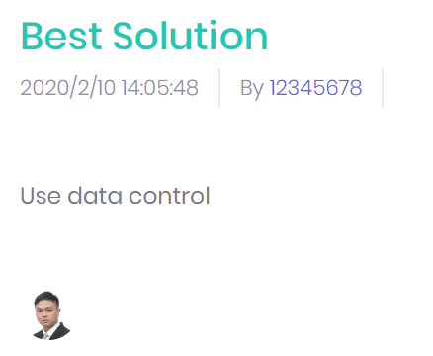

User can share their learning experience in Blog system which is posted in profile page.

User can tip the author with credit and can add the blogpost to favorite. Administrator can highlight the blogpost to make it more obvious on blog list page. 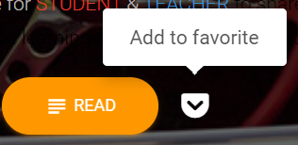

User can view their credit transaction histories in My Wallet. If they need credit, they can purchase through PayPal API.

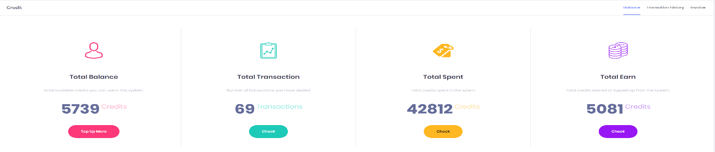

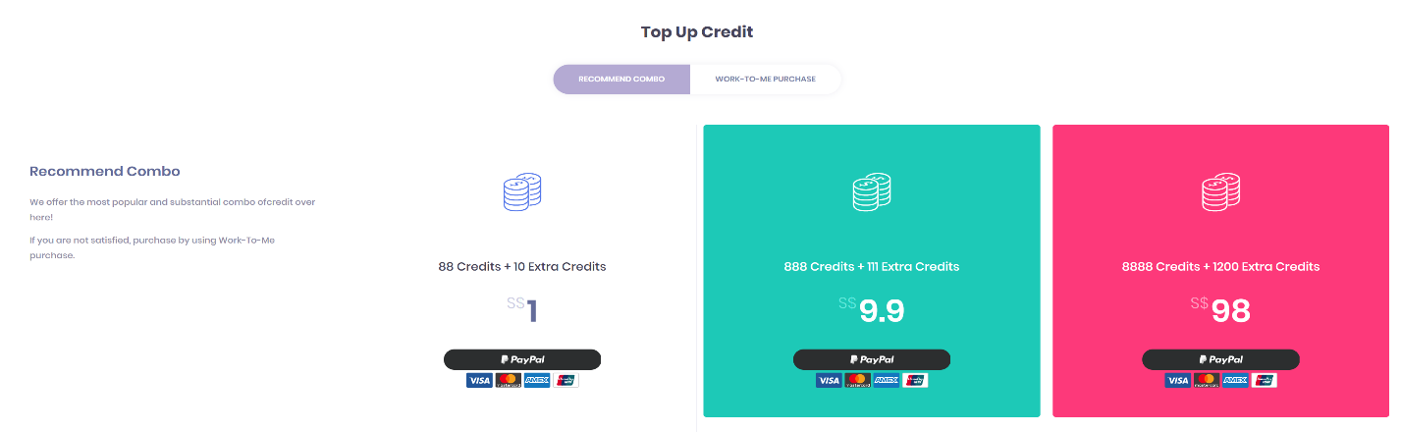

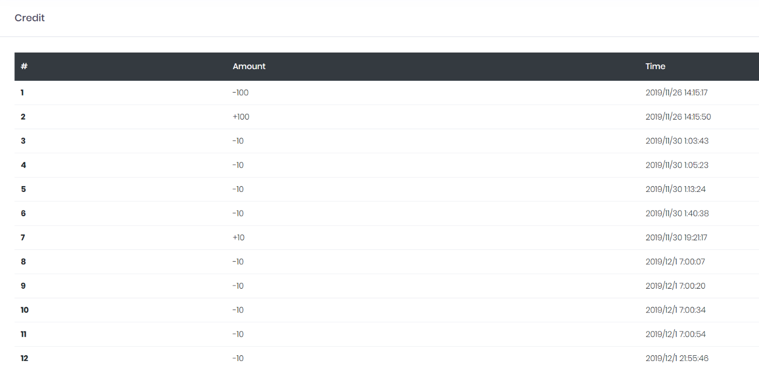

With sufficient credits, user can redeem books from shop.

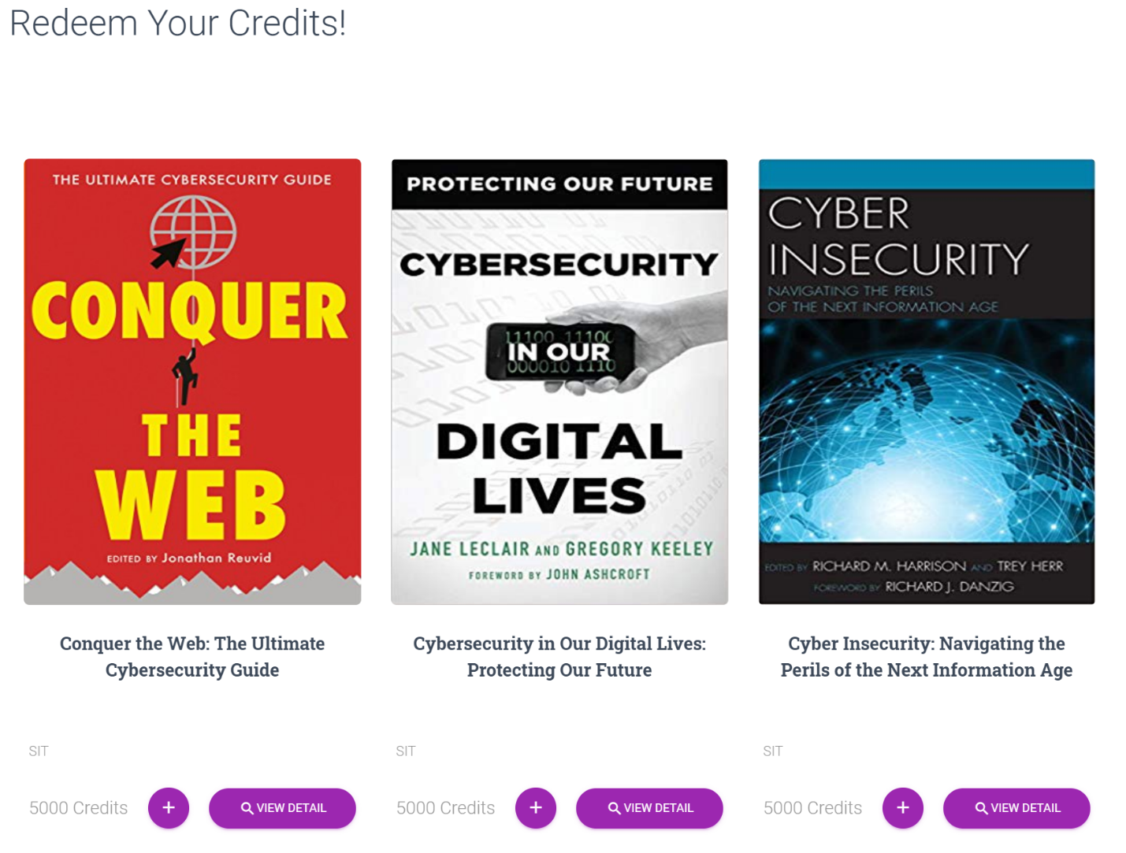

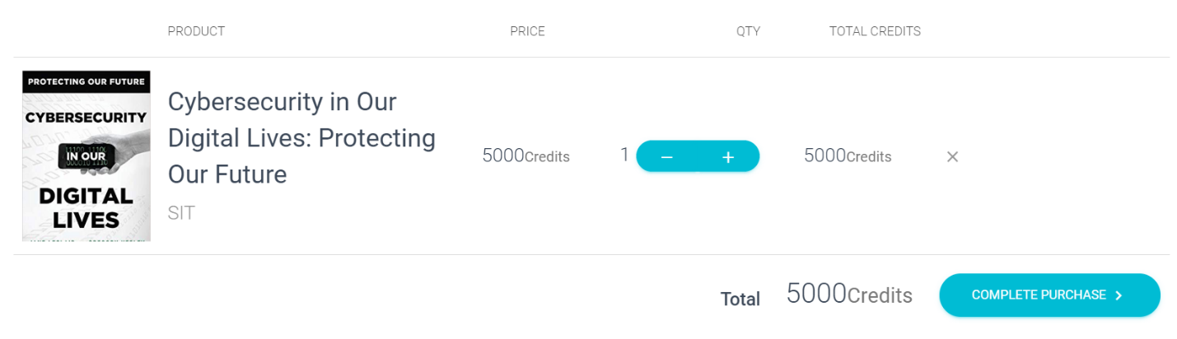

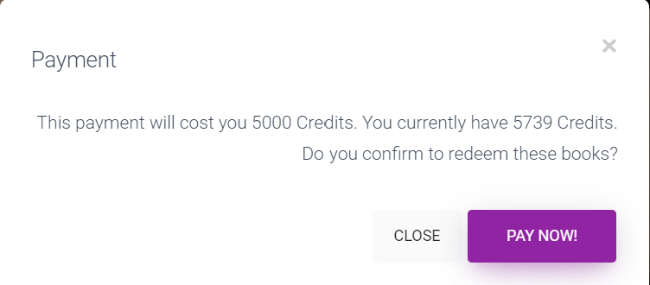

Successful Payment will be store in My Wallet>Invoice



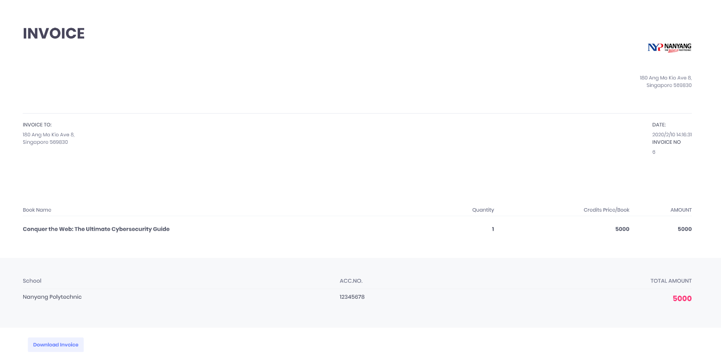

User can download the invoice into pdf form using Download Invoice Button



User can see the overall ranking in the system.

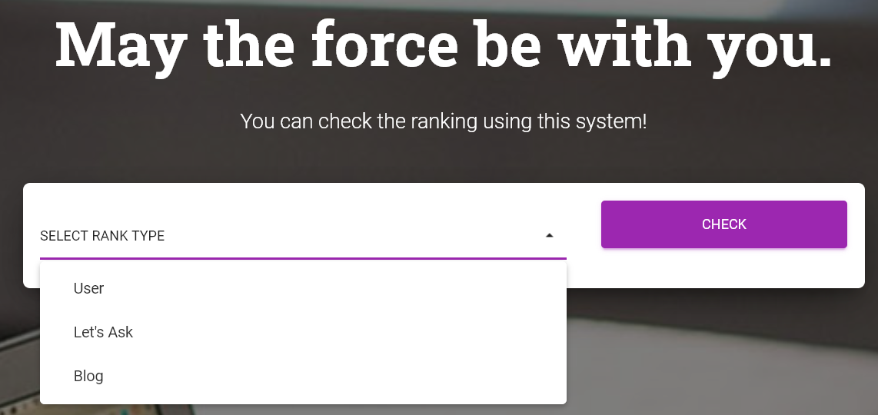

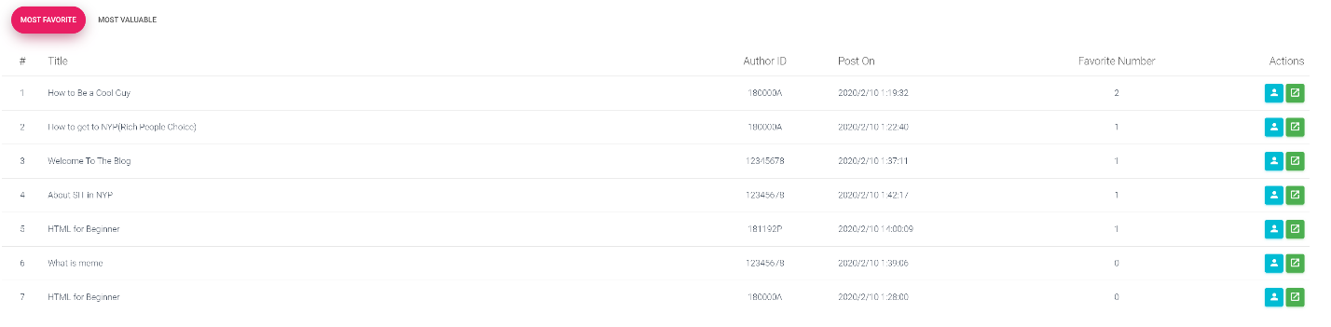

Invitation code encourage user to bring more new users to the system as it gives extra credit to both inviters and new users.

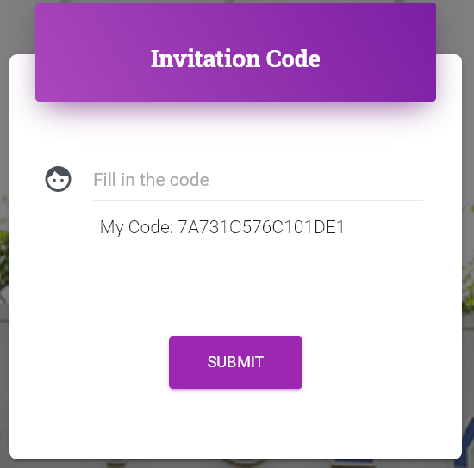

Notification menu have user to notice what have they done inside NYP Journey and can redirect them to the page with a click of button.

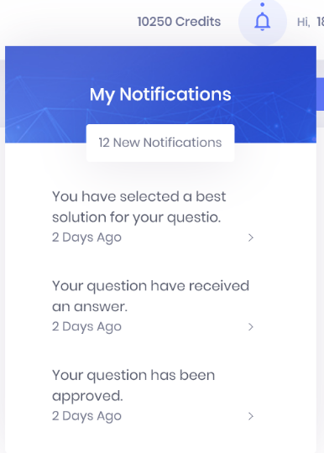

By using management tools, administrator can have a glance of the data of the websites. Search bar also enhance their efficiency.

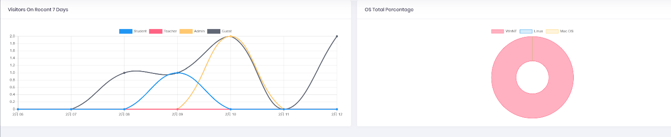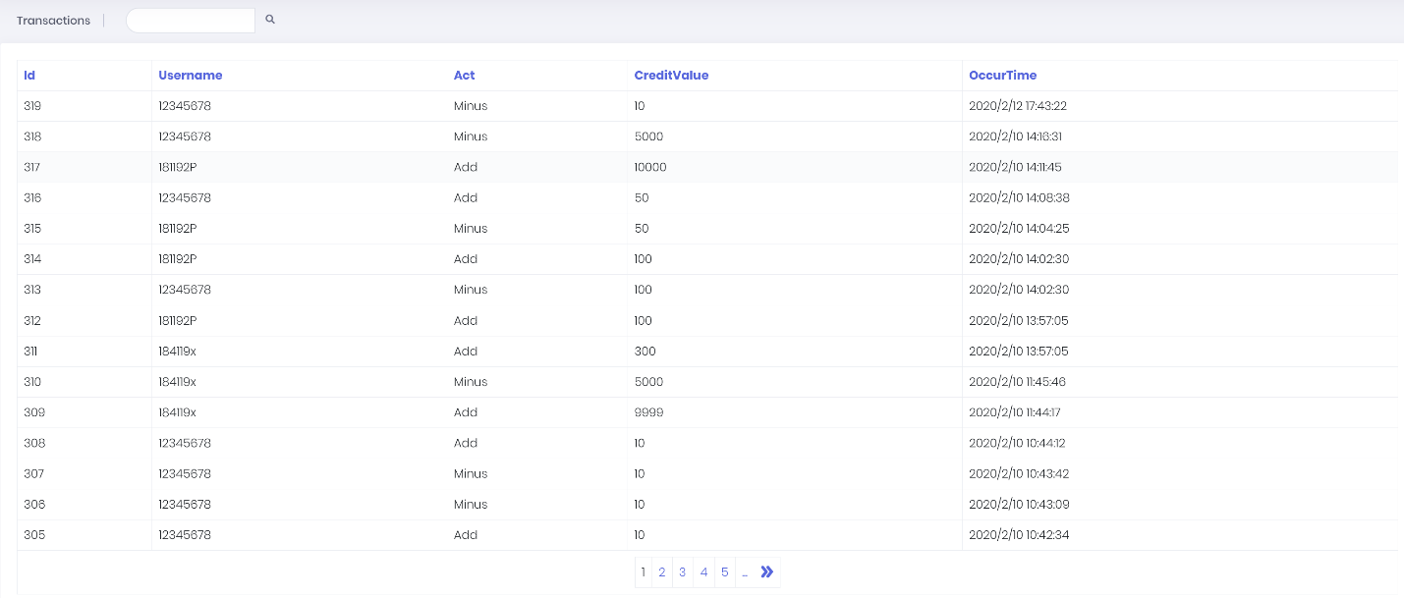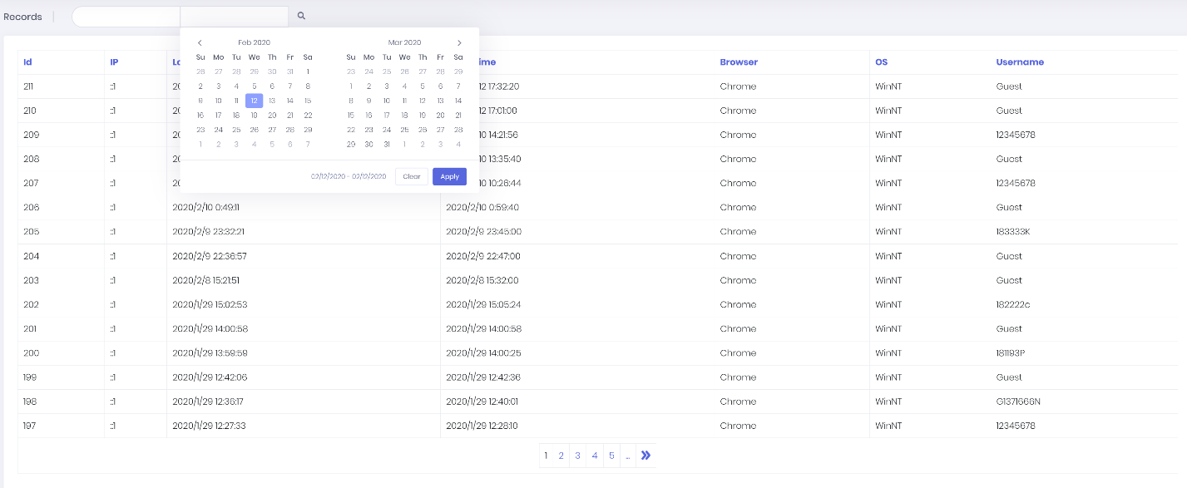

They can also monitor and delete users’ account using the tools.

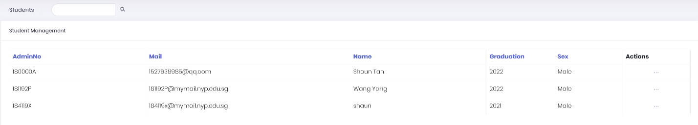

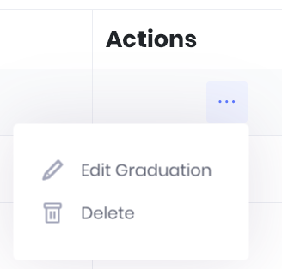

If user has any problem, they can report the issue by using feedback or contact, they can also navigate to the FAQ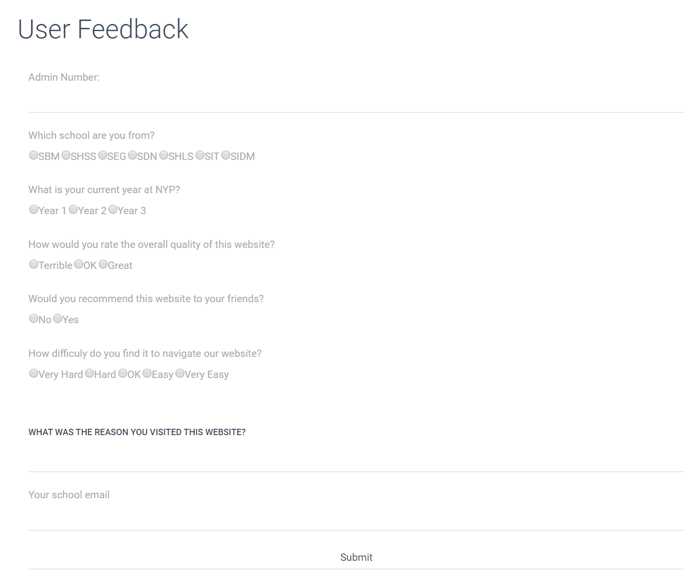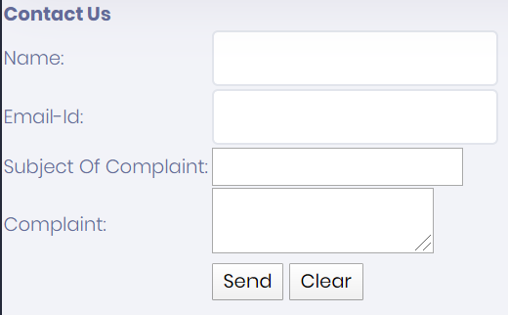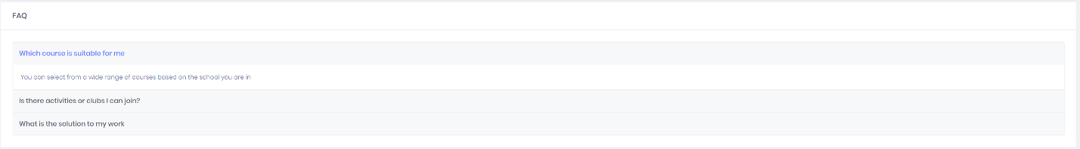

**Documented by: Wang Yang**

Future Enhancements

We hope to add an online course system to our website so that user can be more interactive with NYP Journey. At the same time, teachers and students can play a more different roles. The teacher can post the course using the system and student can pay the credit to view it. In addition, we hope to enhance the verification of the login and registration, we want to use the NRIC API provided by Singapore Government to verify whether the teacher’s registration information is real.

Furthermore, the forget password feature can no longer send a unencrypted password to user email, but instead, a change-password link to user email, so that user can have more choice whether to get back their original password or to change to a new one instead.

Lastly, we wish to establish a chat functions for user and administrator to communicate more effectively instead of sending a report so that admin can solve the problem faster and user will be more satisfied.

**Documented by: Wang Yang**

Conclusion

In conclusion, we believe that our application has successfully fulfil the users’ need as it can effectively keep the old user active and at the same time attract more new users. The credit system makes the user have a positive feedback from the system as with the use of shop system, the credit are no longer a currency that only give in but also give out and the invitation code can help the user have a easier way of earning and invite more new blood.

The management tools ease the manpower of the management as now everything can be simply a button click instead of accessing the database manually.

As a group, through the semester project, we have improved our coding experience and are now more familiar about C# as well as ASP.NET.